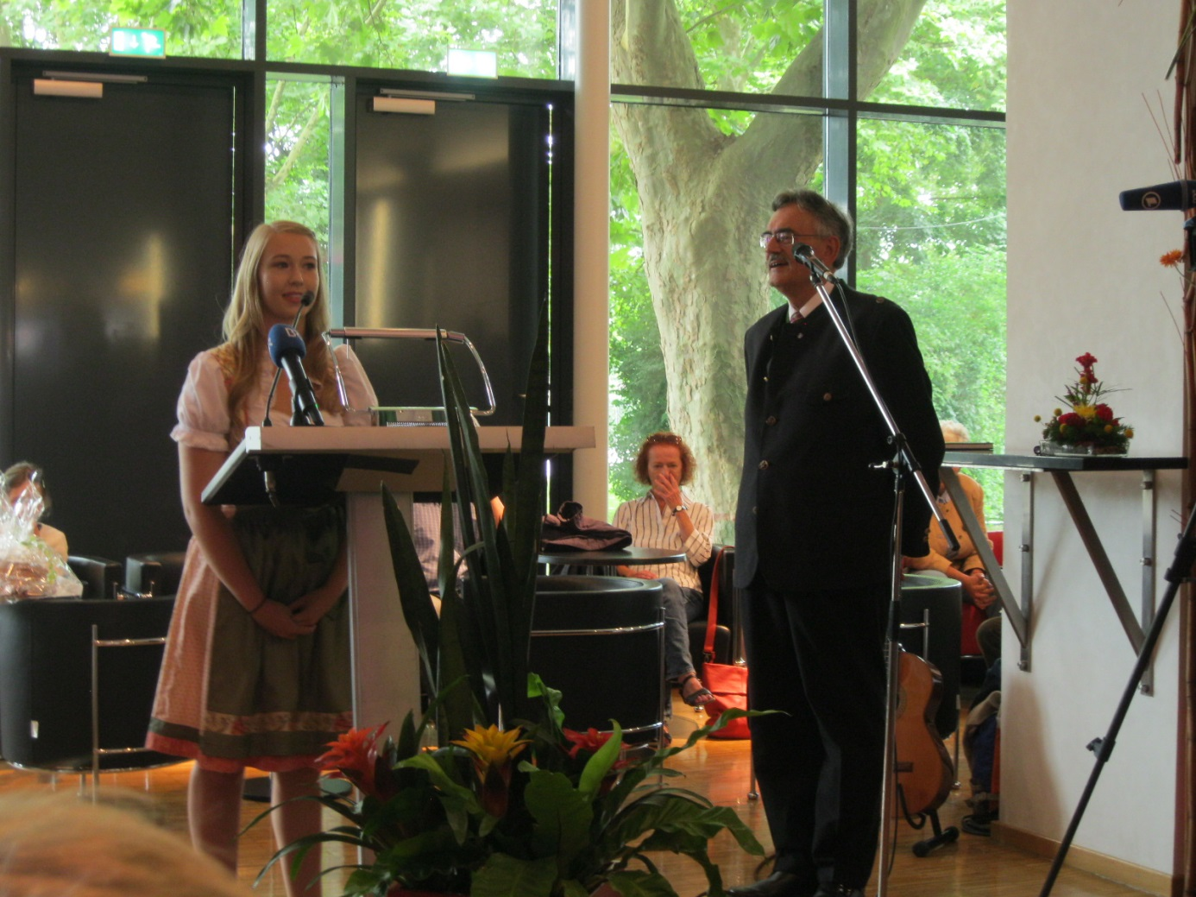
Englische Dankesworte von Laura Obermeier an den Präsidenten, Prof. Dr. Wolfgang A. Herrmann, für seine Laudatio im mittelbairischen Dialekt – in Anspielung auf die Umstellung der Master-Studiengänge an der Technischen Universität München auf Englisch:
Dear Mr. President,
thank you for this precious speech! In the history of presenting the award “Bairische Sprachwurzel” it really did set a milestone. Why?
As a so called Bavarian native speaker you profess the Bavarian language in reference to your work in a modern technical institution.
Bringing English as an indispensable part of modern universities and the Bavarian language on one level with standard German is what philosophers would call the unity of opposites or in Latin “coincidentia oppositorum”.
So congratulations! Well done and keep going!

